Cost Optimization In AWS

What is Cost Optimization in AWS?
Cost optimization in AWS means using AWS cloud resources in most efficient and cost-effictive way without compromising performance, reliability, and security.
Cost optimization means:
Paying only for what you use
Avoiding over-provisioning
Choosing the right pricing models
Continuously monitoring and improving spend
Goal: Maximize value while minimizing unnecessary cost.

Ways to Optimize Cost in AWS
1️⃣ Right-Sizing Resources
Use instance types and sizes that match workload needs.
Downsize underutilized EC2/RDS
Move from provisioned to on-demand or serverless where suitable
Tools: Compute Optimizer, CloudWatch

2️⃣ Use Appropriate Pricing Models
Choose based on workload pattern:
On-Demand – short-term, unpredictable
Reserved Instances (RI) – steady workloads (up to 72% savings)
Savings Plans – flexible compute discounts
Spot Instances – fault-tolerant jobs (up to 90% savings)

3️⃣ Auto Scaling
Scale resources up/down based on demand:
EC2 Auto Scaling Groups
ECS/EKS auto scaling
DynamoDB on-demand
Avoid paying for idle capacity.

4️⃣ Storage Optimization
Move infrequently used data to cheaper tiers:
  - S3 → IA → Glacier → Deep Archive
Delete unused EBS snapshots/volumes
Enable S3 lifecycle policies

5️⃣ Serverless & Managed Services
Reduce infrastructure overhead:
AWS Lambda
Fargate
DynamoDB
S3 + API Gateway
You pay per request/usage.

6️⃣ Turn Off Idle Resources
Stop:
Dev/Test EC2 outside business hours
Unused RDS instances
Idle load balancers & NAT Gateways
Automate using Lambda + EventBridge or Instance Scheduler.

7️⃣ Data Transfer Optimization
Keep traffic within same AZ/Region
Use CloudFront to reduce outbound traffic
Avoid unnecessary cross-region replication

8️⃣ Optimize Architecture
Use caching (ElastiCache, CloudFront)
Use asynchronous processing (SQS)
Choose cost-effective databases (Aurora vs RDS vs DynamoDB)

AWS Services for Cost Optimization
1.Dashboard: Here we can see the Home page for cost and billings
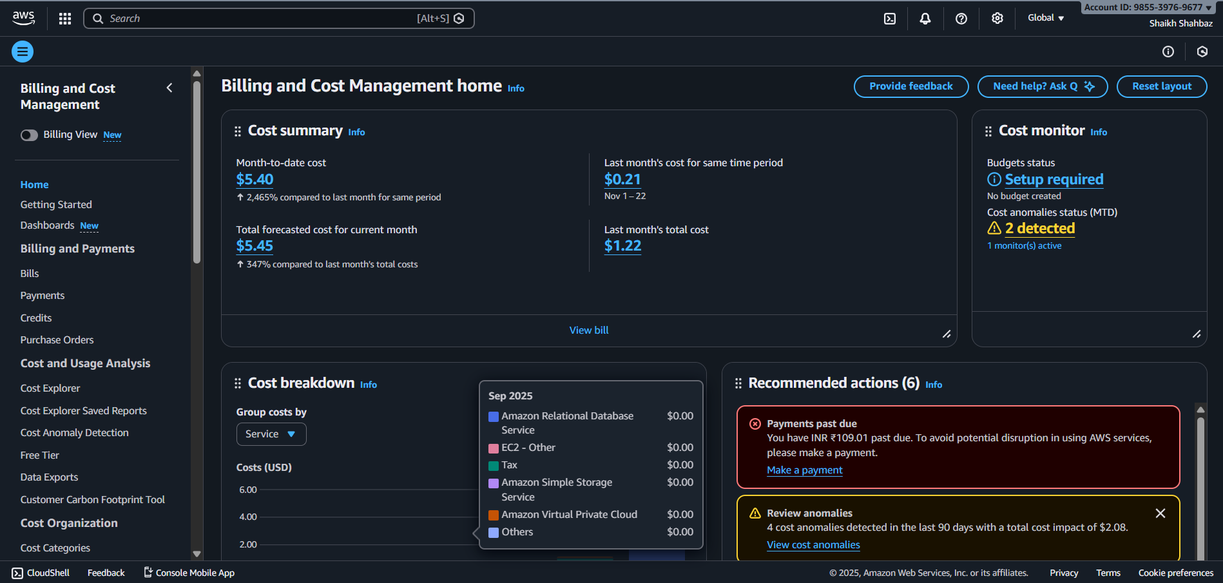
2.AWS Cost Explorer: Analyze and visualize spending
Definition
AWS Cost Explorer is a built-in AWS billing tool that helps you analyze, visualize, and understand your AWS costs and usage over time using interactive graphs and reports. It enables you to identify cost trends, high-spending services, and opportunities for optimization.
Steps to Use AWS Cost Explorer
- Enable Cost Explorer (first time only)
  - Go to AWS Console → Billing Dashboard → Cost Explorer
  - Click Launch Cost Explorer → Enable Cost Explorer
(Data may take up to 24 hours to appear.)
- Open Cost Explorer
  - Navigate to Billing → Cost Explorer → Cost & Usage.
- Select Time Range
  - Choose predefined ranges (last month, last 3 months) or set a custom range.
  - Select Daily or Monthly granularity.
- Apply Filters
  - Filter by Service, Account, Region, Usage type, or Tags to narrow results.
- Group By
  - Group costs by Service, Linked account, Region, Instance type, or Tag to see breakdowns.
- View Charts and Table
  - Analyze costs in graph or table format.
- Use Forecast (Optional)
  - Switch to Forecast to view predicted future spend.
- Save or Export Report
  - Save the report or download CSV for offline analysis.

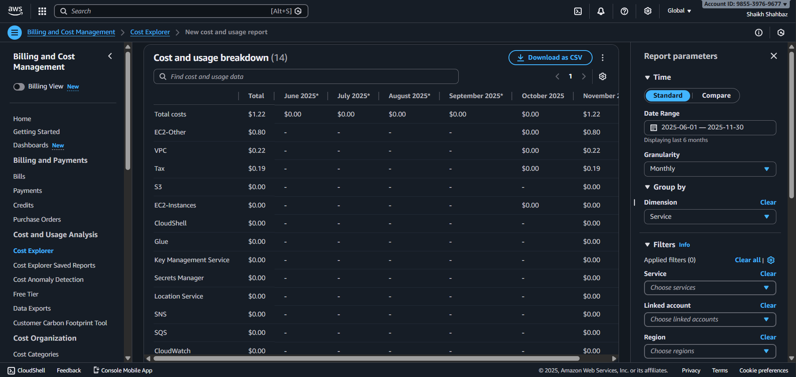

3.AWS Budgets: Set cost/usage alerts
Definition
AWS Budgets is a cost management service that lets you set custom budgets for cost, usage, or reservations and sends alerts when your actual or forecasted usage exceeds defined thresholds, helping you control and manage AWS spending.
Steps to Use AWS Budgets (Set Cost/Usage Alerts)
- Open AWS Budgets
  - Go to AWS Console → Billing Dashboard → Budgets.
  - Click Create budget.
- Choose Budget Type
  - Select one:
    - Cost budget – total spend
    - Usage budget – service usage (e.g., hours, GB)
    - RI/Savings Plans budget – utilization/coverage
- Set Budget Details
  - Enter:
    - Budget name
    - Period (Monthly/Quarterly/Yearly)
    - Start date
    - Budget amount (e.g., $500)
- Add Filters (Optional)
  - Limit budget to specific services, linked accounts, regions, or tags.
- Configure Alerts
  - Set alert thresholds (e.g., 80%, 100% of budget).
  - Choose trigger: Actual or Forecasted.
  - Enter email recipients (or SNS topic).
- Review and Create
  - Review settings and click Create budget.
- Monitor Budget
  - View budget status in Budgets dashboard and receive alerts when thresholds are crossed.

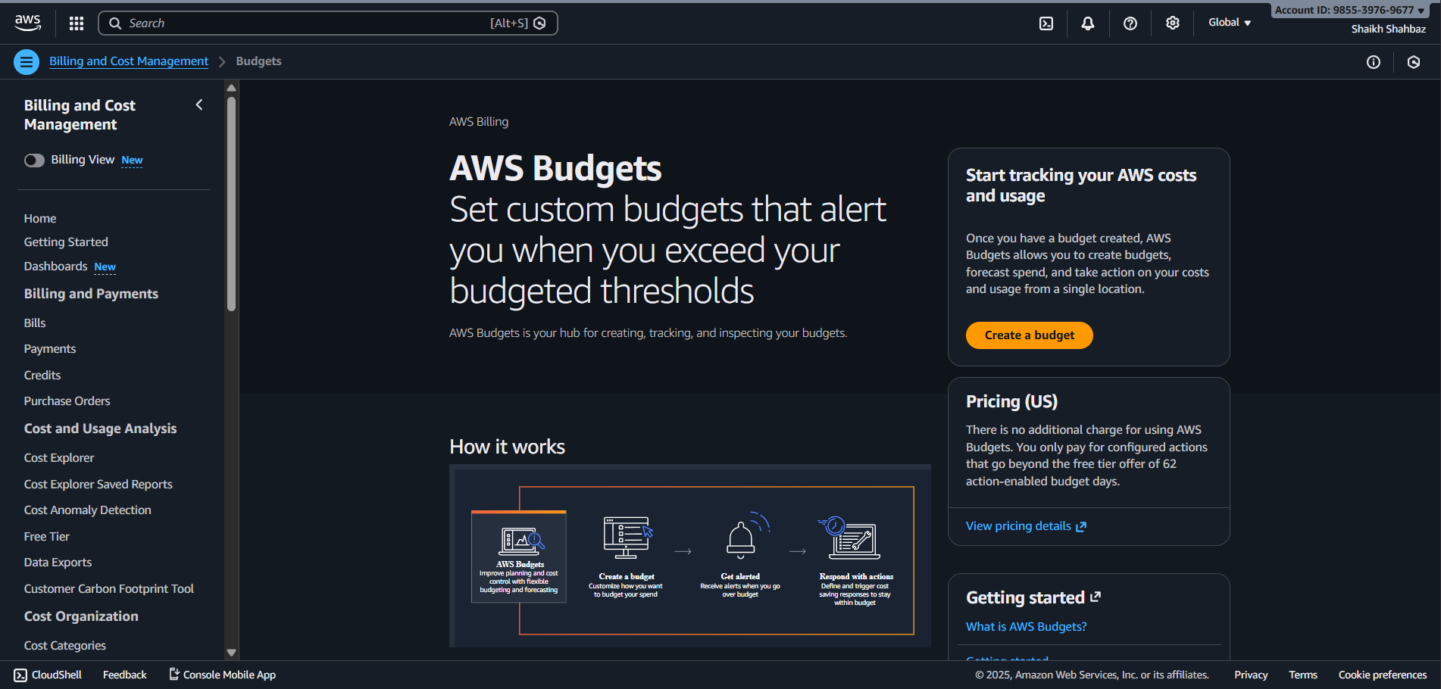

4.AWS Cost Anomaly Detection: Detect unusual spend
Definition
AWS Cost Anomaly Detection is an AWS cost management feature that uses machine learning to continuously monitor your AWS spending and automatically detect unusual or unexpected cost spikes. It alerts you when anomalies occur so you can investigate and control unexpected spend.
Steps to Use AWS Cost Anomaly Detection
- Open Cost Anomaly Detection
  - Go to AWS Console → Billing Dashboard → Cost Anomaly Detection.
- Create an Anomaly Monitor
  - Click Create monitor.
  - Choose monitor type:
    - AWS services (e.g., EC2, S3)
    - Linked account
    - Cost allocation tags (e.g., Project, Env)
    - Or Custom (specific services/accounts).
  - Give the monitor a name and create it.
- Create an Alert Subscription
  - Click Create subscription.
  - Select the monitor(s).
  - Set:
    - Alert threshold (e.g., anomaly impact ≥ $10).
    - Frequency (immediate, daily, weekly).
  - Add email recipients or SNS topic.
- Review and Create
  - Review settings and click Create subscription.
- Monitor Anomalies
  - Detected anomalies appear in the dashboard.
  - You’ll receive alerts with details like service, account, and cost impact.
- Investigate & Act
  - Drill into the anomaly to find root cause (e.g., new EC2 launched, data transfer spike).
  - Take corrective action to stop unnecessary spend.

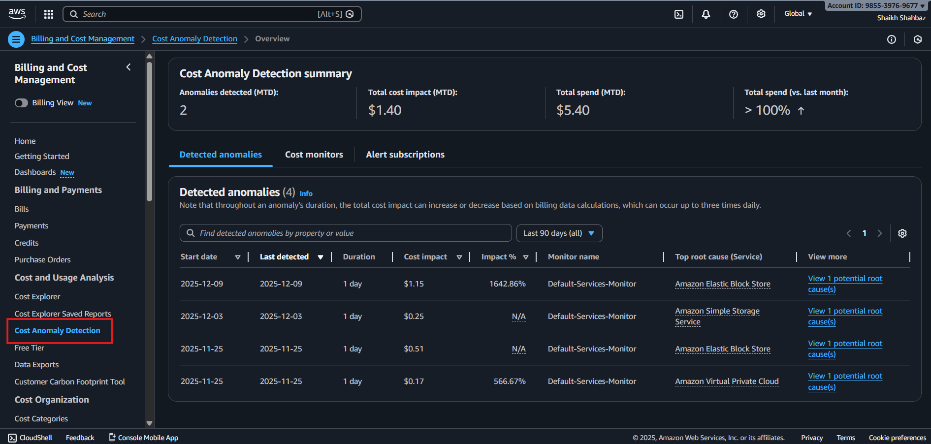
5.AWS Cost Optimizer: Right-size EC2, ASG, Lambda, EBS
Definition
AWS Compute Optimizer is a service that uses machine learning to analyze your resource utilization and provides right-sizing recommendations for EC2 instances, Auto Scaling Groups (ASG), Lambda functions, and EBS volumes to improve performance and reduce cost.
Steps to Use AWS Compute Optimizer (Right-Sizing)
- Open Compute Optimizer
  - Go to AWS Console → Compute Optimizer.
- Opt In (First Time Only)
  - Click Get started and Enable Compute Optimizer for your account/region.
  - It starts collecting metrics from CloudWatch.
⏳ Recommendations appear after 12–24 hours (sometimes up to 3 days).
- View Recommendations Dashboard
  - See summaries for EC2, ASG, Lambda, and EBS.
- Select Resource Type
  - Choose one: EC2 instances, Auto Scaling groups, Lambda functions, or EBS volumes.
- Review Recommendations
  - For each resource, view:
    - Current configuration
    - Recommended size/type
    - Estimated cost savings
    - Performance risk level
- Filter & Sort
  - Filter by finding type (Over-provisioned, Under-provisioned) or sort by savings.
- Implement Changes
  - Resize EC2/ASG, adjust Lambda memory, or change EBS volume type/size based on recommendations.
- Monitor Continuously
  - Recheck regularly as workloads change.

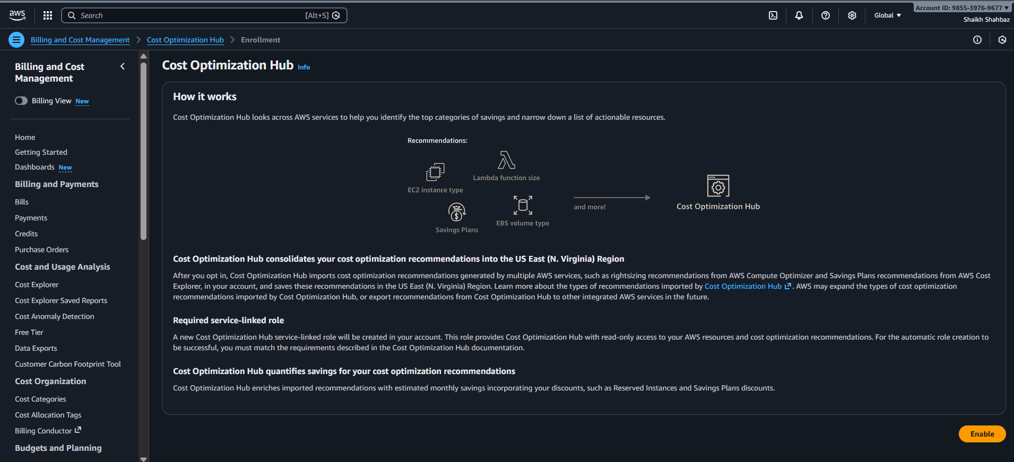
6.AWS Trusted Advisor: Cost-saving recommendations
Definition
AWS Trusted Advisor is an AWS service that provides real-time guidance and best practice recommendations across five categories—Cost Optimization, Security, Performance, Fault Tolerance, and Service Limits. For cost optimization, it identifies opportunities to reduce AWS spending by detecting unused or underutilized resources.
Steps to Use AWS Trusted Advisor for Cost-Saving Recommendations
- Open Trusted Advisor
  - Go to AWS Console → Trusted Advisor.
- View Dashboard
  - You’ll see checks grouped by categories.
  - Select Cost Optimization.
- Review Cost Checks
Common checks include:
  - Low utilization EC2 instances
  - Idle/underutilized load balancers
  - Unassociated Elastic IPs
  - Underutilized EBS volumes
  - Idle RDS instances
  - Savings Plans / RI optimization
- Open a Specific Check
  - Click a check to view affected resources and estimated monthly savings.
- Analyze Impact
  - Review details like region, resource ID, and recommended action.
- Take Action
  - Resize, stop, delete, or purchase RIs/Savings Plans as suggested.
- Refresh Checks
  - Click Refresh to get the latest results (some auto-refresh periodically).
- Track Status
  - Mark items as resolved after applying fixes and monitor savings.

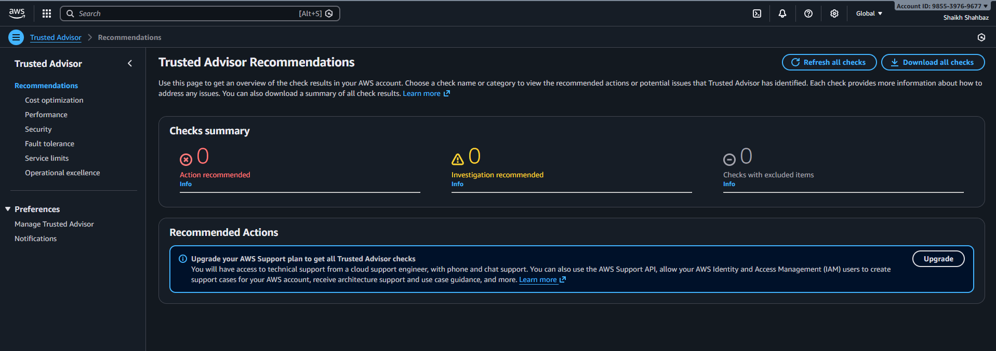
7.AWS Pricing Calculator: Estimate costs before deployment
Definition
AWS Pricing Calculator is a free AWS tool that helps you estimate the cost of AWS services before deployment by modeling your architecture and expected usage. It provides a detailed monthly cost breakdown so you can plan budgets and compare options.
Steps to Use AWS Pricing Calculator
- Open AWS Pricing Calculator
  - Go to AWS Pricing Calculator website from AWS.
- Create an Estimate
  - Click Create estimate.
- Add a Service
  - Choose a service (e.g., EC2, S3, RDS, Lambda).
- Configure Usage
  - Enter details such as:
    - Region
    - Instance type/size
    - Number of instances
    - Storage, data transfer, requests, hours
- Add to Estimate
  - Click Add to my estimate to include the service.
- Repeat for Other Services
  - Add all components of your architecture.
- Review Cost Summary
  - View the monthly total and per-service breakdown.
- Save or Share Estimate
  - Save, export (CSV), or share the estimate link.
- Compare Options (Optional)
  - Modify configurations to compare costs (e.g., On-Demand vs Savings Plans).
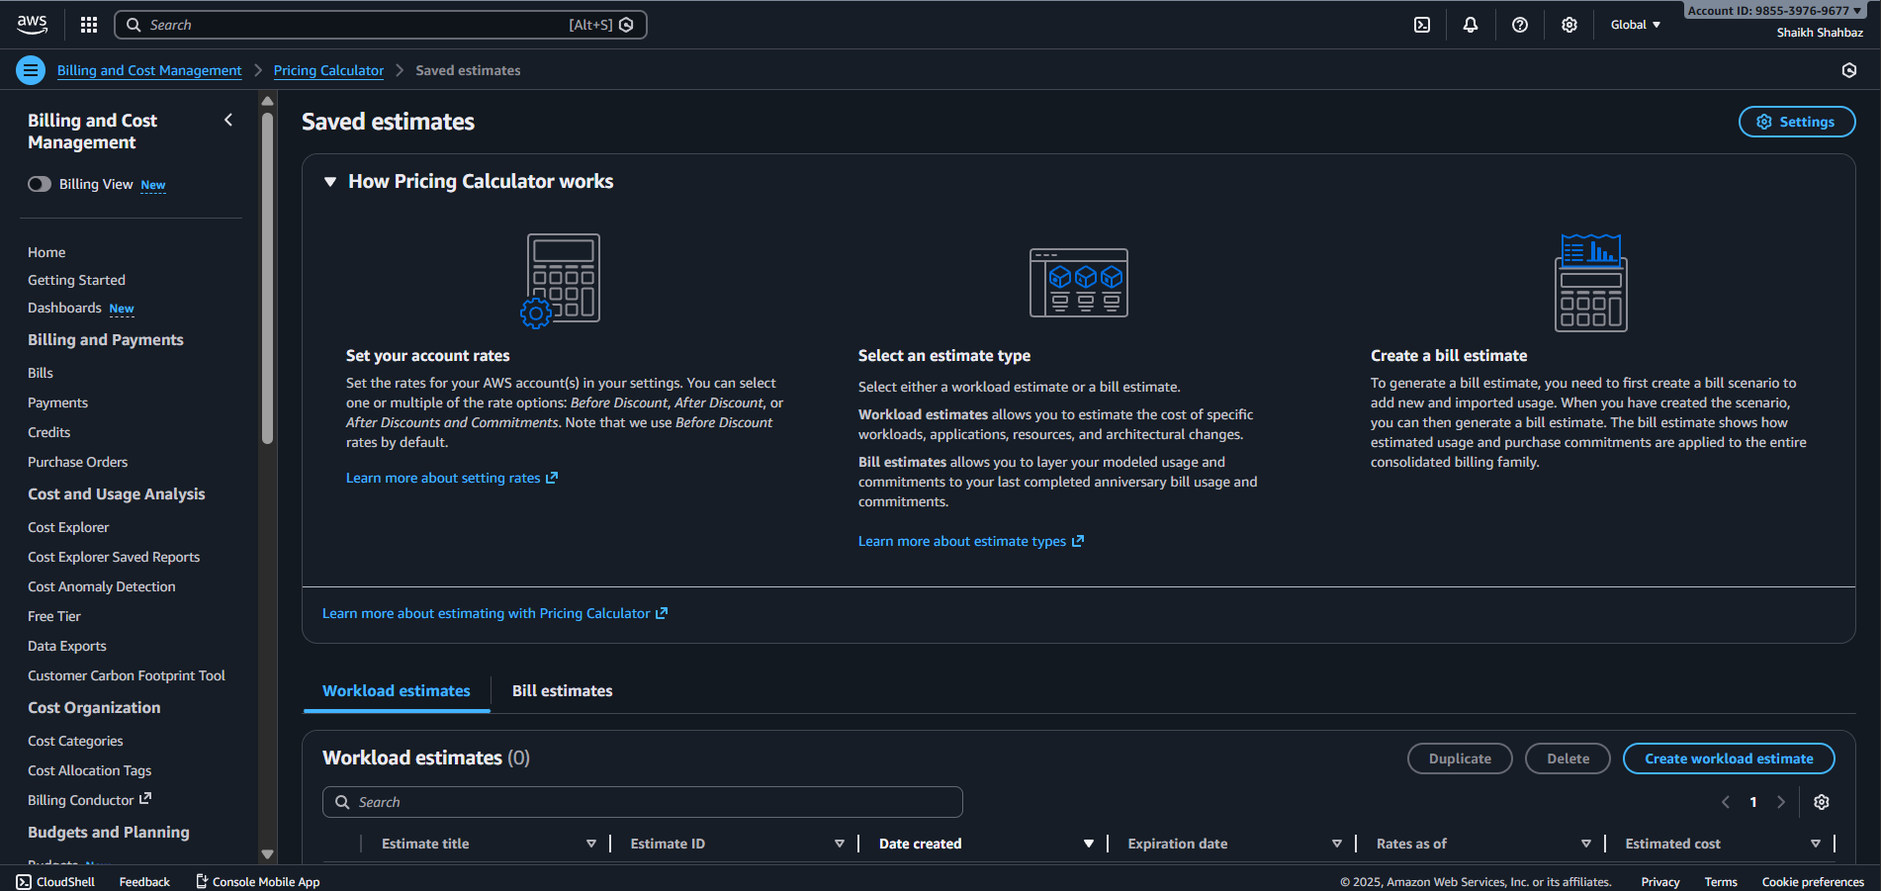
8.AWS Billing Dashboard: Track invoices and usage
Definition
AWS Billing Dashboard is the central console in AWS that provides a high-level view of your account’s charges, usage, invoices, and payment status. It helps you monitor current month spend, review past bills, and understand overall AWS usage.
Steps to Use AWS Billing Dashboard (Track Invoices & Usage)
- Open Billing Dashboard
  - Sign in to AWS Console → click account name → Billing Dashboard.
- View Month-to-Date Spend
  - On the home page, see current month charges and trend graphs.
- Check Service-wise Usage
  - Click Bills → select a month → expand services (EC2, S3, etc.) to see usage and cost.
- View Invoices
  - Go to Bills → choose billing period → Download invoice (PDF/CSV).
- Review Payment History
  - Navigate to Payments to see past payments and balances.
- Access Cost Tools
  - From the left menu, open Cost Explorer, Budgets, Cost Anomaly Detection for deeper analysis.
- Manage Billing Preferences
  - Go to Billing preferences to enable alerts, PDF invoices, and receive notifications.
- Download Reports
  - Use Cost & Usage Reports to export detailed billing data to S3.

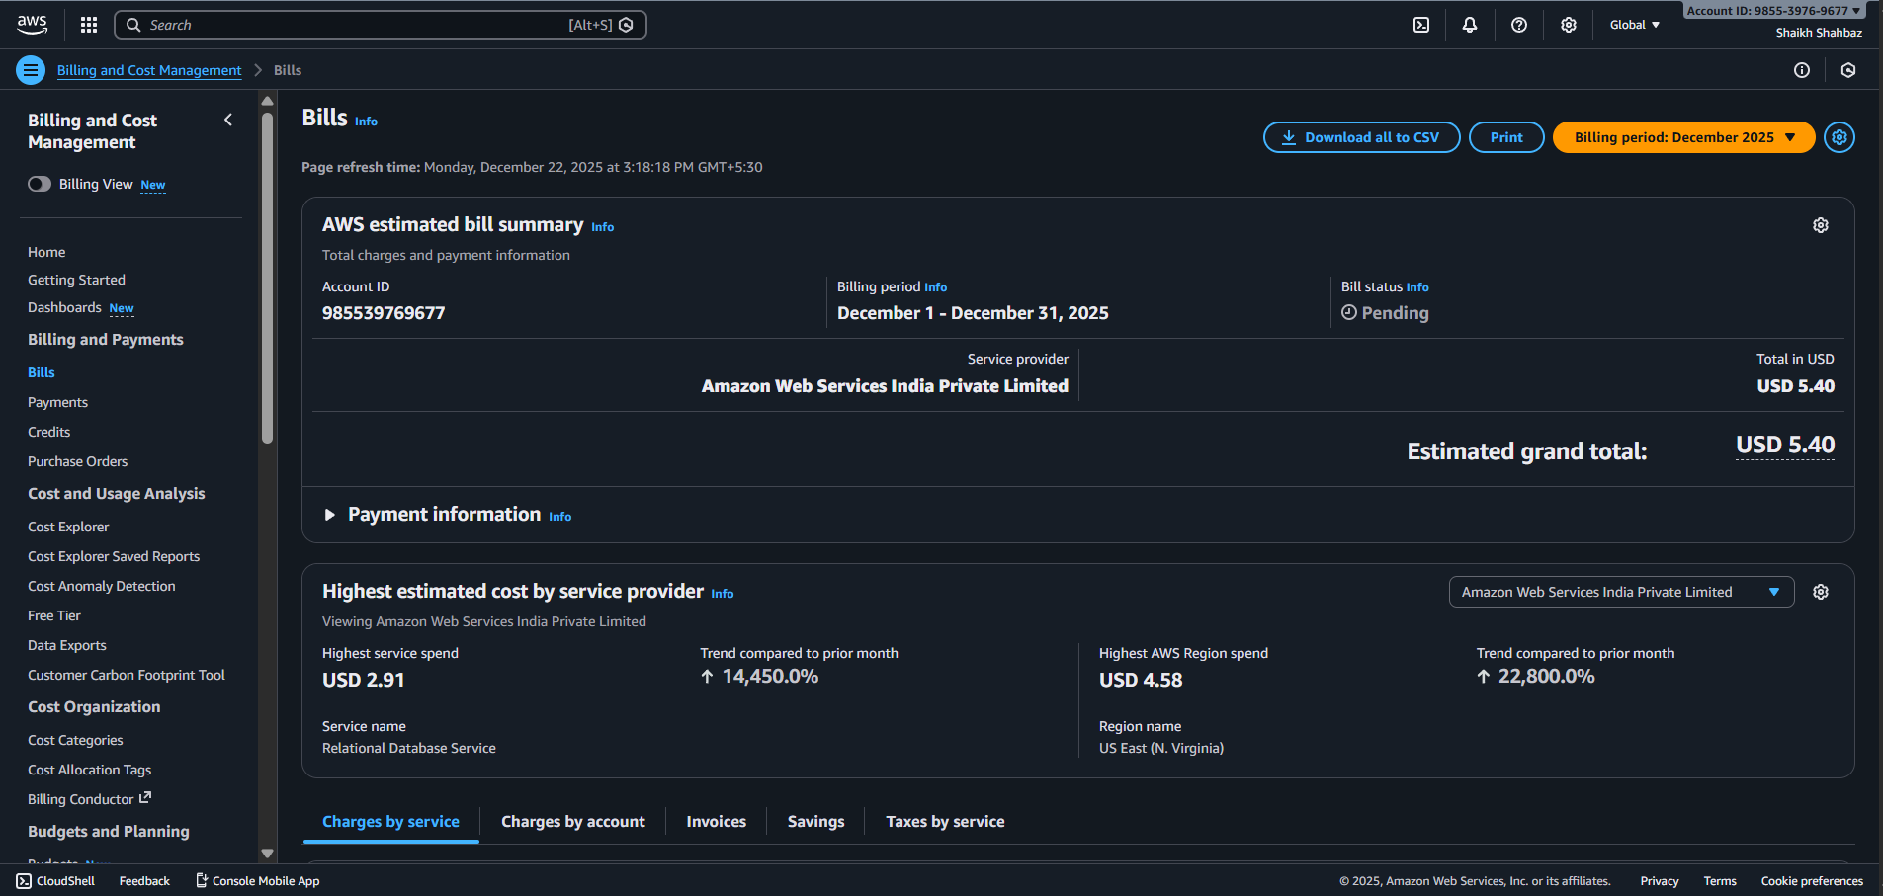
9.Savings Plans: Long-term cost discounts
Definition
AWS Savings Plans are flexible pricing models that provide significant cost discounts (up to ~72%) in exchange for committing to a consistent amount of compute usage (measured in $/hour) for a 1-year or 3-year term. They automatically apply to eligible usage, helping reduce long-term AWS compute costs.
Steps to Use AWS Savings Plans
- Open Savings Plans
  - Go to AWS Console → Billing Dashboard → Savings Plans.
- View Recommendations
  - Click Recommendations to see suggested commitment levels based on your past usage.
- Choose a Savings Plan Type
  - Compute Savings Plan – applies to EC2, Fargate, and Lambda across regions (most flexible).
  - EC2 Instance Savings Plan – applies to specific instance family in a region (higher discount).
- Select Term & Payment Option
  - Term: 1 year or 3 years.
  - Payment: No upfront, Partial upfront, All upfront.
- Set Hourly Commitment
  - Choose the $/hour amount you commit to spend.
- Review Estimated Savings
  - Check projected monthly cost and savings.
- Purchase Savings Plan
  - Review and confirm purchase.
- Monitor Utilization
  - Go to Savings Plans → Utilization & Coverage to ensure you’re using your commitment effectively.

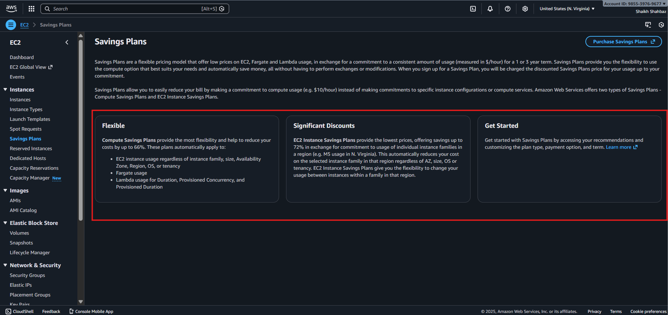
10.S3 Lifecycle Policies: Automatic tiering
Definition
S3 Lifecycle policies are rules you configure on an S3 bucket to automatically transition objects between storage classes (like Standard → IA → Glacier) or expire/delete them based on age, helping optimize storage costs without manual effort.
Steps to Use S3 Lifecycle Policies (Automatic Tiering)
- Open S3 Console
  - Go to AWS Console → S3 and select your bucket.
- Go to Management Tab
  - Click the Management tab in the bucket.
- Create Lifecycle Rule
  - Under Lifecycle rules, click Create lifecycle rule.
- Name the Rule & Scope
  - Enter a rule name.
  - Choose scope: All objects or filter by prefix/tags.
- Choose Lifecycle Actions
  - Select Transition current versions of objects to cheaper classes:
    - After X days → Standard-IA / One Zone-IA
    - After Y days → Glacier / Glacier Deep Archive
  - (Optional) Select Expire objects after Z days.
- Set Days for Transitions
  - Define when each transition should occur.
- Review and Create Rule
  - Review settings and click Create rule.
- Monitor
  - S3 automatically applies transitions as objects reach the defined age.

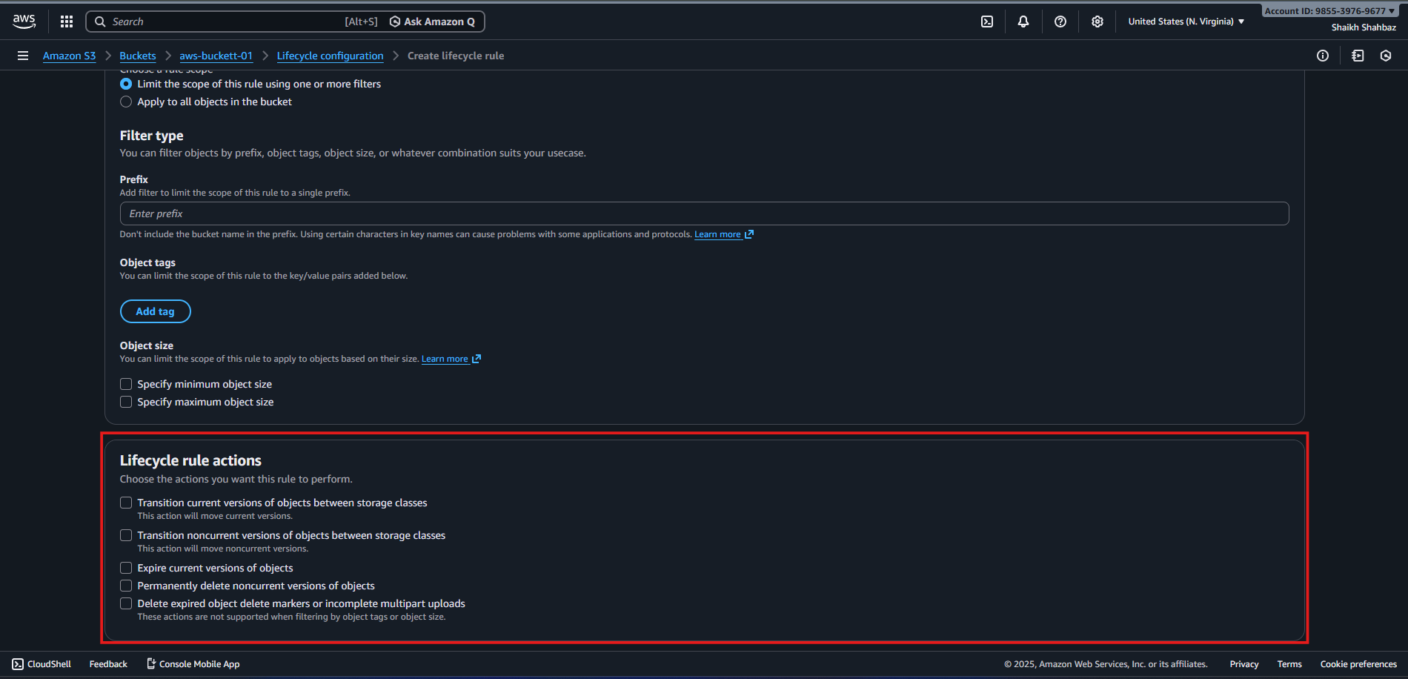

11.Amazon EventBridge Scheduler: Start/stop non-prod resources and we can schedule ec2 start/stop.
Definition
Amazon EventBridge Scheduler is a fully managed scheduling service that lets you run AWS actions at specific times or intervals. It’s commonly used to automatically start and stop non-production resources, such as EC2 instances, to reduce costs during off-hours.
Steps to Use EventBridge Scheduler to Start/Stop EC2 Instances
🔹 Prerequisite
- An IAM role with permissions to start/stop EC2 instances (ec2:StartInstances, ec2:StopInstances).
Schedule to Start EC2
- Open EventBridge Scheduler
  - Go to AWS Console → Amazon EventBridge → Scheduler.
- Create Schedule
  - Click Create schedule.
- Define Schedule Pattern
  - Choose Cron-based or Rate-based.
  - Example: Cron to start at 9 AM daily:
  - cron(0 9 * * ? *)
- Select Target
  - Target service: AWS service
  - API: EC2 → StartInstances
- Configure Input
  - Provide instance IDs:
  - {
  - "InstanceIds": ["i-0123456789abcdef0"]
  - }
- Select IAM Role
  - Choose the role with EC2 start permissions.
- Review and Create
  - Review settings and click Create schedule.
Schedule to Stop EC2
Repeat the same steps, but:
API: EC2 → StopInstances
Example cron to stop at 7 PM daily:
cron(0 19 * * ? *)
Input:
{ "InstanceIds": ["i-0123456789abcdef0"]}
Result
EC2 instances will automatically start and stop at scheduled times, helping reduce costs for dev/test or non-prod environments.

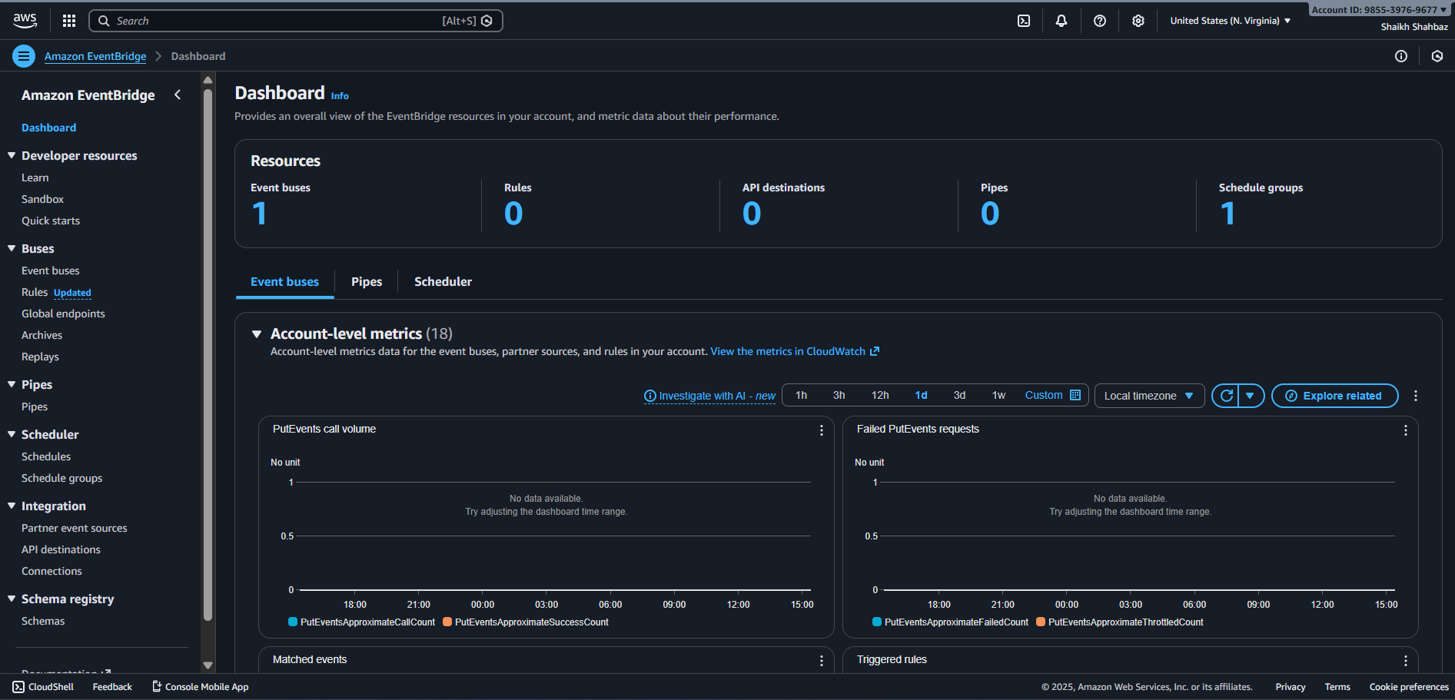
Best Practices to Reduce AWS Cost
✅ Design & Architecture
Design for elasticity (scale on demand)
Prefer managed & serverless services
Use stateless applications
✅ Governance
Use multiple AWS accounts (prod, dev, test)
Apply Service Control Policies (SCPs)
Set budgets and alerts
✅ Resource Management
Tag resources: Project, Owner, Env
Regularly delete:
  - Unused EC2, EBS, snapshots
  - Old AMIs
  - Orphaned ENIs & ELBs
✅ Monitoring & Review
Weekly/monthly cost reviews
Use Cost Explorer reports
Act on Trusted Advisor checks
✅ Pricing Strategy
Use Savings Plans/RIs for steady workloads
Use Spot for batch/CI jobs
Reevaluate pricing every quarter
✅ Storage & Backup
Right-size volumes
Use lifecycle rules
Avoid keeping backups forever
✅ Development
Limit log retention (CloudWatch Logs)
Optimize Lambda memory/timeouts
Avoid chatty APIs

Cost Optimization Across Key AWS Services
EC2
Right-size
Use ASG, Spot, Savings Plans
Stop idle instances
S3
Lifecycle rules
Intelligent-Tiering
Delete incomplete uploads
RDS/Aurora
Resize instances
Use storage autoscaling
Stop non-prod DBs
Consider Aurora Serverless
Lambda
Tune memory & timeout
Remove unused functions
CloudWatch
Set log retention
Avoid excessive custom metrics
NAT Gateway
Reduce cross-AZ traffic
Use VPC endpoints for S3/DynamoDB

Example Cost Optimization Strategy
For a web app:
ALB + Auto Scaling EC2 (Savings Plan)
Spot for background jobs
CloudFront for static content
S3 lifecycle → Glacier
Budgets + alerts
Trusted Advisor review monthly

Key Principles (Well-Architected)
Adopt consumption model
Measure overall efficiency
Stop spending on undifferentiated heavy lifting
Analyze and attribute expenditure
Use managed services

Conclusion
AWS cost optimization is a continuous process, not a one-time task.
By:
Right-sizing
Choosing right pricing models
Automating scaling
Monitoring spend
Using AWS native tools
you can significantly reduce cloud costs while maintaining performance and reliability.

